**Project Design Phase-II**

**Technology Stack (Architecture & Stack)**

|  |  |
| --- | --- |
| Date | 01 Nov 2023 |
| Team ID | NM2023TMID04457 |
| Project Name | Building a website using canva |

**Technical Architecture:**

The Deliverable shall include the architectural diagram as below and the information as per the table1 & table 2

**Example: Order processing during pandemics for offline mode**

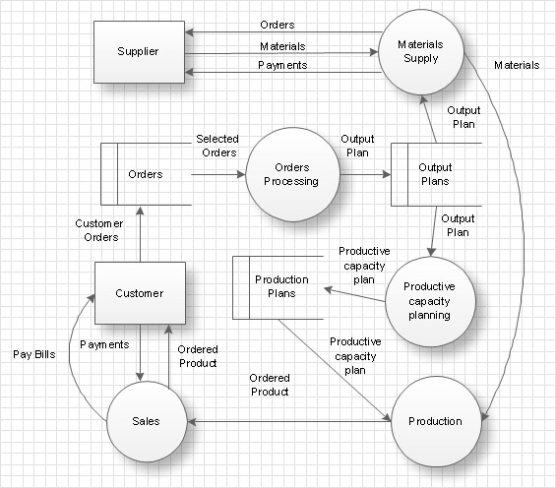

**Table-1: Components & Technologies:**

|  |  |  |  |
| --- | --- | --- | --- |
| **S. No** | **Component** | **Description** | **Technology** |
|  | Location | Select a suitable location for the cafe, taking into account factors like foot traffic, accessibility, and proximity to your target. | Geographic Information Systems (GIS) and mapping tools. |
|  | Space and Layout | Plan the interior design and layout of the cafe to accommodate seating, a kitchen area, counter space, and any additional features like outdoor seating. | Implement Computer-Aided Design (CAD) software for efficient cafe layout planning. |
|  | Equipment | Acquire the necessary equipment, including coffee machines, grinders, ovens, refrigerators, dishwashers, and furniture. | Integrate IoT-enabled and smart appliances for operational efficiency. |
|  | Menu | Develop a menu that includes coffee, tea, pastries, sandwiches, salads, or any other food and beverage items you plan to offer. | Employ digital menu boards and POS systems for dynamic and efficient menu management. |
|  | Staffing | Hire and train baristas, kitchen staff, servers, and any other personnel required to run the cafe efficiently. | Scheduling and HR management software |
|  | Suppliers | Establish relationships with suppliers for coffee beans, baked goods, and other ingredients to ensure a consistent and quality supply of products. | Implement procurement and supply chain management software for automated supplier interactions. |
|  | Books | Stock a variety of books, including novels, non-fiction, and children's books. | Offer e-books and e-readers, with e-reader devices and management platforms. |
|  | Wi-Fi | Provide Wi-Fi access for customers who want to work or study. | Provide secure Wi-Fi using Wi-Fi management software. |
|  | Reservation System | An online reservation system allows customers to book tables, enhancing user experience and streamlining cafe operations. | HTML,CSS,JavaScript |
|  | SEO Integration | Basic SEO practices improve the website's visibility in search engine results, attracting more organic traffic. | SEO tools, plugins, and best practices. |

**Table-2: Application Characteristics:**

| **S. No** | **Characteristics** | **Description** | **Technology** |
| --- | --- | --- | --- |
|  | Scalability | The website should be able to handle increased user traffic and content growth. | Scalable hosting infrastructure and CMS. |
|  | Security | Implement robust security measures to protect user data and safeguard against cyber threats. | SSL, security plugins, encryption. |
|  | Performance | Ensure the website loads quickly and offers a smooth user experience. | Content optimization, fast hosting. |
|  | User-Friendly Interface | Create an intuitive and visually appealing design for a positive user experience. | Responsive web design, user interface design. |
|  | SEO-Friendly | Implement SEO best practices to improve search engine visibility. | SEO tools, meta tags, keyword optimization. |
|  | Mobile Optimization | Optimize the website for mobile devices to cater to users on smartphones and tablets. | Responsive design, mobile optimization. |
|  | Accessibility | Ensure the website is accessible to all users, including those with disabilities. | Accessibility standards, assistive technologies |
|  | Data Management | Efficiently manage and back up data to prevent data loss and ensure data security. | Data backup solutions, databases. |
|  | Analytics and Monitoring | Use analytics tools to monitor user behavior and track website performance. | Google Analytics, monitoring tools. |
|  | Social Media Integration | Use analytics tools to monitor user behavior and track website performance. | Social media widgets, APIs. |